H.T No
Regulations:
A18

Sreenidhi Institute of Science and Technology
(An Autonomous Institution)
Code No: 7K406 Date: 30-Sept-2021(AN)

B.Tech II-Year II- Semester External Examination, Sept/Oct-2021 (Supplementary)
CONSTRUCTION ENGINEERING AND MANAGEMENT (CIVIL)

Time: 3 Hours Max.Marks:70

Note: a) No additional answer sheets will be provided.
b) All sub-parts of a question must be answered at one place only, otherwise it will not be valued.
c) Missing data can be assumed suitably.

ANSWER ANY 5 OUT OF 8 QUESTIONS. EACH QUESTION CARRIES 14 MARKS.

Bloom's Cognitive Levels of Learning (BCLL)

Remember | L1 | Apply | L3 | Evaluate | L5
Understand | L2 | Analyze | L4 | Create | L6

 |  |  | BCLL | CO(s) | Marks
1. |  | 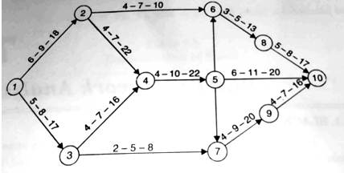  The network for a construction project is shown in fig . The three time estimates for each activity are given along each activity arrow. Compute (a) expected time of completion of each activity,(b) earliest expected time for each even | L4 | CO1 | [14M]
2. | a) | Discuss the scope and use of precast concrete construction methods. | L3 | CO2 | [7M]
 | b) | Elaborate the usage of construction methods for bridges. | L3 | CO2 | [7M]
3. | a) | Differentiate mechanized vs conventional construction methods. | L3 | CO3 | [7M]
 | b) | Explain sources of funds for construction site. | L4 | CO3 | [7M]
4. | a) | Explain the concept of planning and organizing of construction site. | L3 | CO4 | [7M]
 | b) | Discuss resource constraints and conflicts. | L3 | CO4 | [7M]
5. | a) | Determine the use of Building information Modeling in the construction industry. | L4 | CO5 | [7M]
 | b) | How health and safety can improve the project environment? | L3 | CO5 | [7M]
6. | a) | Explain different types of contracts. | L2 | CO6 | [7M]
 | b) | Describe the process contract duration and price. | L3 | CO6 | [7M]
7. | a) | Discuss about network diagram. | L3 | CO1 | [5M]
 | b) | What are the advantages of modular construction? | L2 | CO2 | [5M]
 | c) | What are the uses of hoist equipment in construction project? | L3 | CO3 | [4M]
8. | a) | How can bar charts are used for construction? | L2 | CO4 | [5M]
 | b) | Describe the role of inspection for construction works. | L3 | CO5 | [5M]
 | c) | Define compression and decompression. | L3 | CO6 | [4M]
-- 00 -- 00 –

